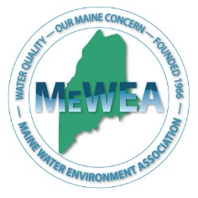
Operator Exchange Form
General Information
Operator Name:
Operator Contact Info:
Certificate Number:
Name of Hosting Facility:
Visit Date:
Host Name(s):
Host Contact Info:

Preliminary Info (fill this out before visit)
List at least three topics you hope to better understand.
What are some issues you have struggled with at your own facility?
How would you like to spend your time during this visit?
What are you hoping to gain/learn from this experience?
Training Info (fill this out after visit)
Time in:
Time out:
How did you spend your time at the hosting facility?
What is the design flow of the facility?
Describe the process configuration (you may attach a process flow diagram)
List 3 examples of how the visiting facility differs from your own.
What process challenges has the visiting facility faced, and how were they dealt with?
List 3 things that you learned during your visit that you might be able to apply to your own process.
Are there any issues that are dealt with differently at your facility that could be useful to the visiting facility?
Do you have any suggestions about how this operator program could be improved in the future?
Would you or anyone at your facility be interested in hosting an operator to visit your facility?
Any other comments or notes.
Visiting Operator Signature: |  |  |  | Date:
Host Signature: |  |  |  | Date:

